**Session 4 Construction of Different VLANS and TRUNKING using cisco packet tracer.**

Constructing different VLANs (Virtual Local Area Networks) and configuring trunking using Cisco Packet Tracer involves a few steps:

Trunking is used in a network to allow multiple VLANs to communicate across network devices (like switches) over a single physical link. It enables the transportation of traffic from different VLANs over the same link, reducing the need for multiple physical connections and ensuring that VLAN segmentation is maintained across the network.

**Step 1: Setting Up the Network Topology**

**Network Architecture**

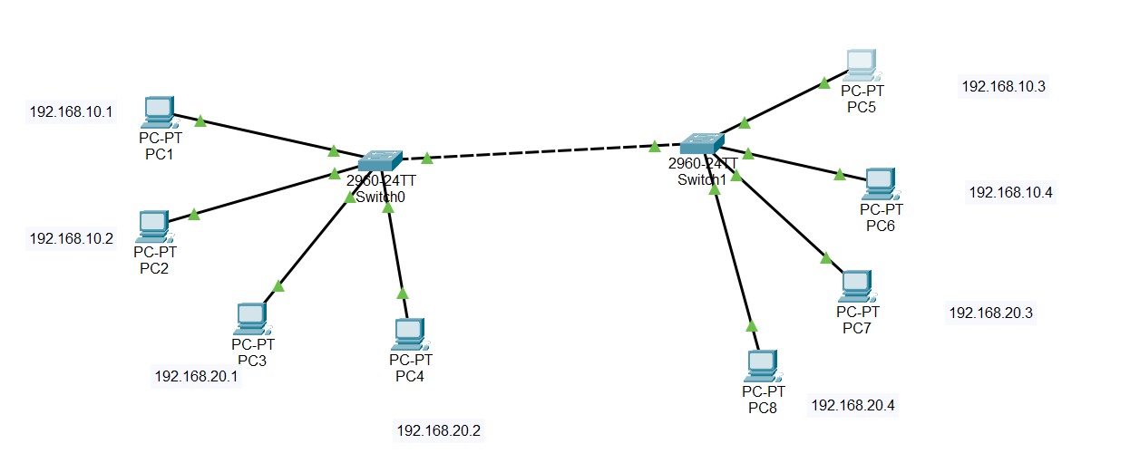

#### Devices:

* **Switch 1 (S1)**
* **Switch 2 (S2)**
* **PCs (End Devices)**
  + **PC1** and **PC2** connected to **S1** (assigned to VLAN 10)
  + **PC3** and **PC4** connected to **S1** (assigned to VLAN 20)
  + **PC5** and **PC6** connected to **S2** (assigned to VLAN 10)
  + **PC7** and **PC8** connected to **S2** (assigned to VLAN 20)

#### VLANs:

* **VLAN 10**: IP range 192.168.10.0/24
* **VLAN 20**: IP range 192.168.20.0/24

#### Trunk Ports:

* **Fa0/24** on both **S1** and **S2**

### Configuration Steps

#### Step 1: Setting Up the Network Topology

1. **Add Devices in Packet Tracer:**
   * Drag and drop two switches (**S1** and **S2**).
   * Add PCs and connect them to the switches using copper straight-through cables.
   * Connect **fa0/24** of **S1** to **fa0/24** of **S2** using a cross-over cable.

**Switch 0 Configuration**

Switch>enable

Switch#configure terminal

Enter configuration commands, one per line. End with CNTL/Z.

**Create VLAN 10**

Switch(config)#vlan 10

Switch(config-vlan)#name VLAN10

Switch(config-vlan)#exit

**Create VLAN 20**

Switch(config)#vlan 20

Switch(config-vlan)#name VLAN20

Switch(config-vlan)#exit

**Assign Ports to VLAN 10:**

Switch(config)#interface range fa0/1 - 4

Switch(config-if-range)#switchport mode access

Switch(config-if-range)#switchport access vlan 10

Switch(config-if-range)#exit

**Assign Ports to VLAN 20:**

Switch(config)#interface range fa0/5 - 8

Switch(config-if-range)#switchport mode access

Switch(config-if-range)#switchport access vlan 20

Switch(config-if-range)#exit

**Set a Port to Trunk Mode- S0**

Switch(config)#interface fa0/24

Switch(config-if)#switchport mode trunk

Switch(config-if)#exit

Switch(config)#

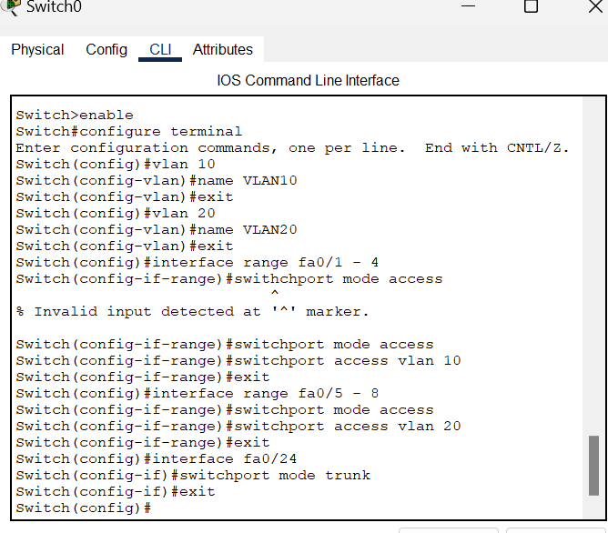

**Switch 1 Configuration**

Switch>enable

Switch#configure terminal

Enter configuration commands, one per line. End with CNTL/Z.

**Create VLAN 10**

Switch(config)#vlan 10

Switch(config-vlan)#name VLAN10

Switch(config-vlan)#exit

**Create VLAN 20**

Switch(config)#vlan 20

Switch(config-vlan)#name VLAN20

Switch(config-vlan)#exit

**Assign Ports to VLAN 10:**

Switch(config)#interface range fa0/1-4

Switch(config-if-range)#switchport mode access

Switch(config-if-range)#switchport access vlan 10

Switch(config-if-range)#exit

**Assign Ports to VLAN 20:**

Switch(config)#interface range fa0/5-8

Switch(config-if-range)#switchport mode access

Switch(config-if-range)#switchport access vlan 20

Switch(config-if-range)#exit

**Configuring Trunking on Switch 1**

Switch(config)#interface fa0/24

Switch(config-if)#switchport mode trunk

Switch(config-if)#exit

Switch(config)#

Switch#

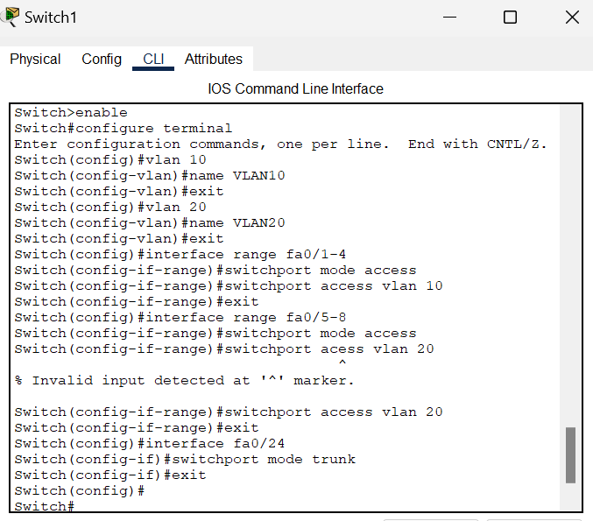

#### Verify Connectivity

1. **Check Trunk Ports:**

Switch# show interfaces trunk

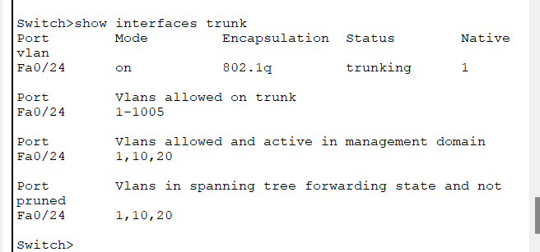

**Check VLANs:**

**Switch# show vlan brief**

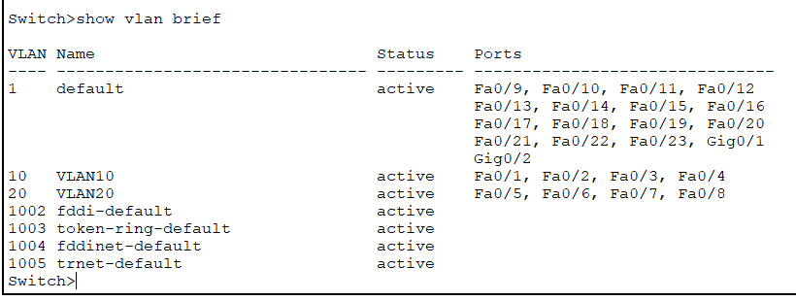

#### Step 5: Configure End Devices

1. **Assign IP Addresses to PCs:**
   * **PC1**: 192.168.10.1/24
   * **PC2**: 192.168.10.2/24
   * **PC3**: 192.168.20.1/24
   * **PC4**: 192.168.20.2/24
   * **PC5**: 192.168.10.3/24
   * **PC6**: 192.168.10.4/24
   * **PC7**: 192.168.20.3/24
   * **PC8**: 192.168.20.4/24

• **Test Connectivity within VLANs:**

* **Ping** from **PC1** to **PC2** (both in VLAN 10)
* **Ping** from **PC3** to **PC4** (both in VLAN 20)
* **Ping** from **PC5** to **PC1** (both in VLAN 10, across switches)

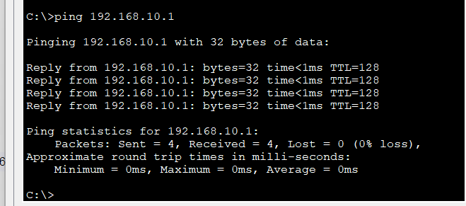

* **Ping** from **PC7** to **PC3** (both in VLAN 20, across switches)

• Verify **that PCs in different VLANs cannot communicate without a router:**

* **Ping** from **PC1** to **PC3** should fail (VLAN 10 to VLAN 20)
* **Ping from PC7 to PC1**